pwd command
this command shows the present working directory.

ls command
It displays the list of the files and folders in the given directory.

ls -l command
ls -l command is used to list files and directories, it displays the contents in a long format with some colour specifications.

cd command
cd command is used to change directory, here in the above example the directory is changed from desktop to Demo.

cd ..
cd .. command is used to go one step back to the parent directory.here i have moved back from Demo to desktop directory.

clear command
clear command is used to clear the terminal screen.

echo command
echo command is used to print string or used to display a line of text.

cd / command
cd / command is used to access the root directory.

ls -f
ls -f command it displays the files without any format and also includes hidden folders and also dose not show any colour specifications.

ls -a command
displays the hidden folder in sorted format.

ls -A
it ignores the hidden file and shows the rest.

cat command for text file
cat command is used to read the data ,here it displays what is there in txt.file.

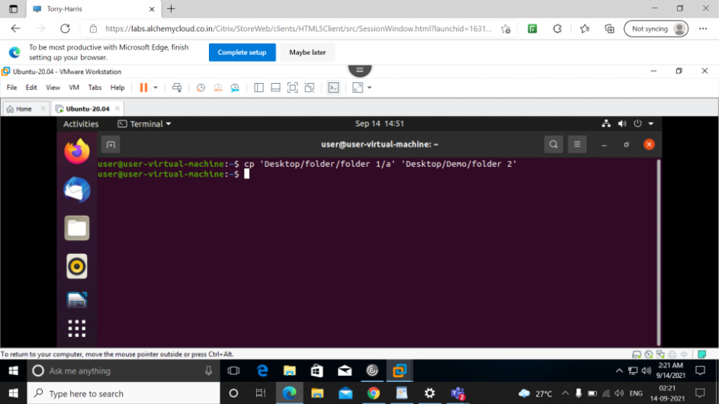

cp command
this command is used to cut the file

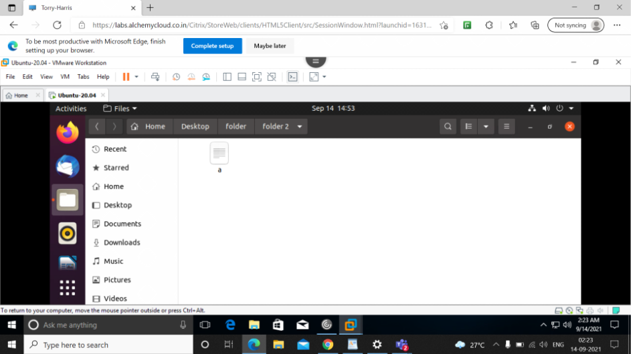
here file named 'a' from folder 1 is copied(cut and pasted) to folder 2

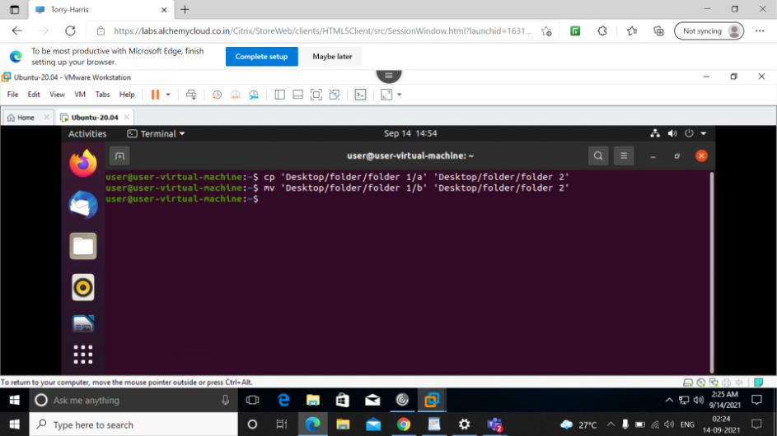

mv command
this command is used to move the file.

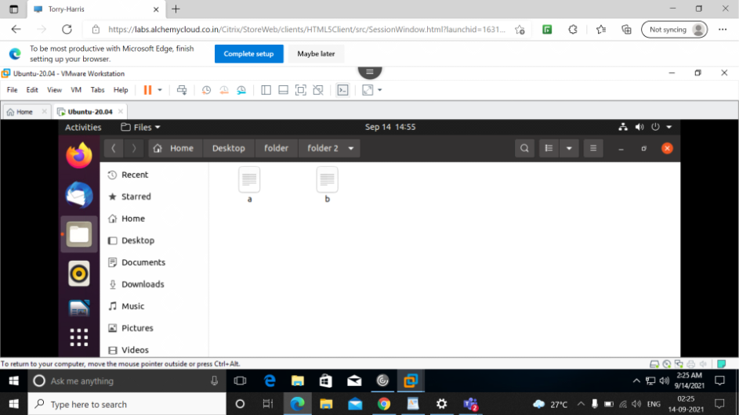

here now file name "b" from folder 1 is moved to folder 2

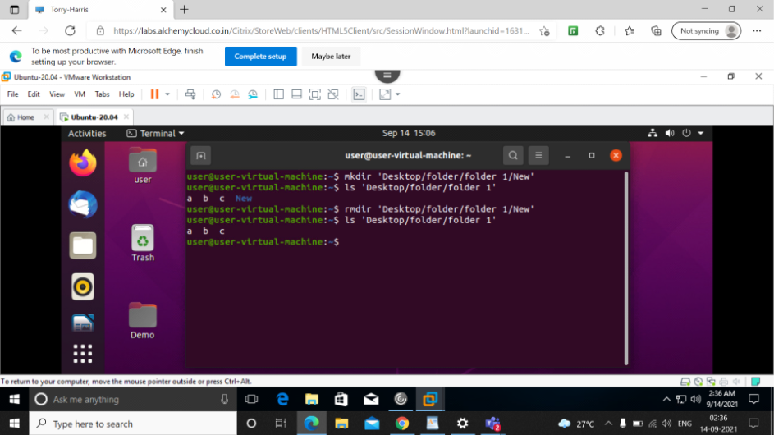
mkdir is used to create new file within the folder
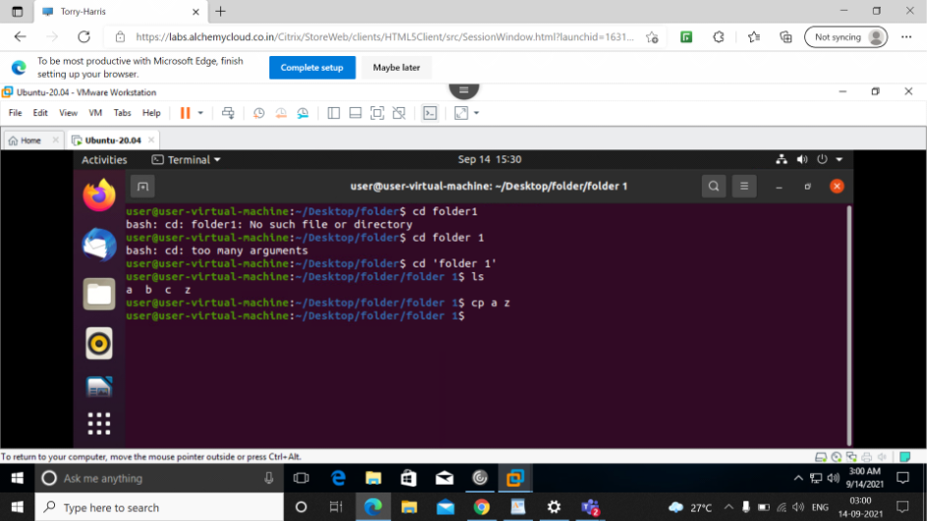
cp command
this command is used to copy the data.

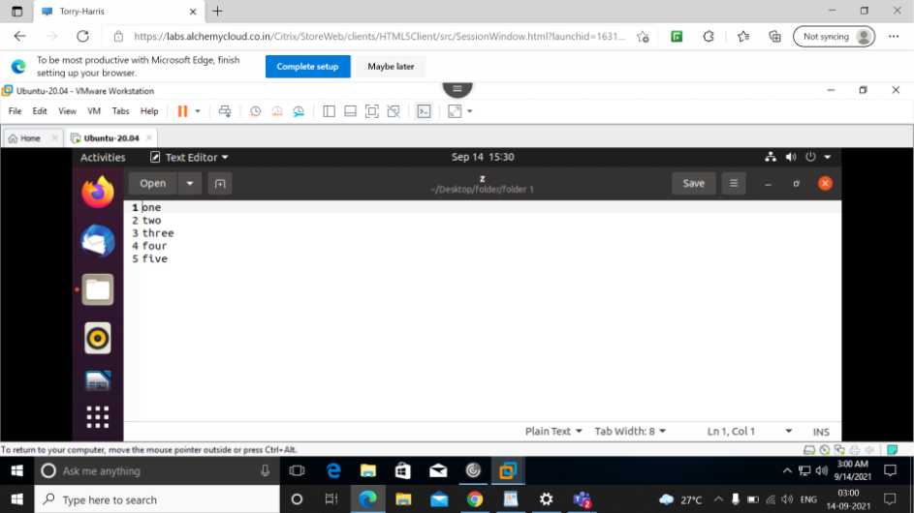

here data from 'a' is copied to 'z'

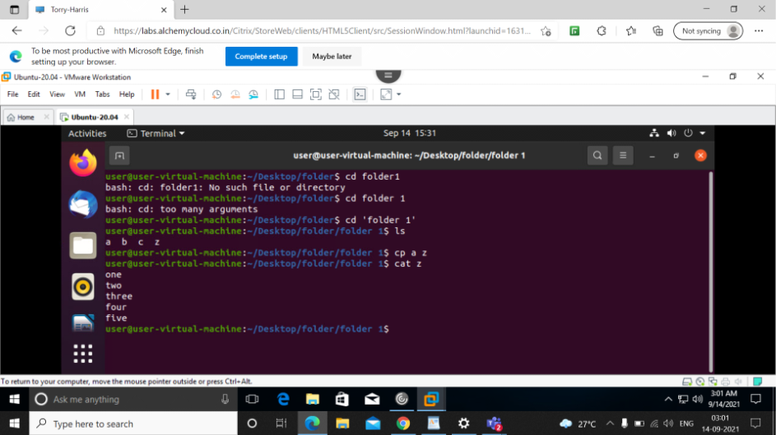
cat z command
displays everything in z.

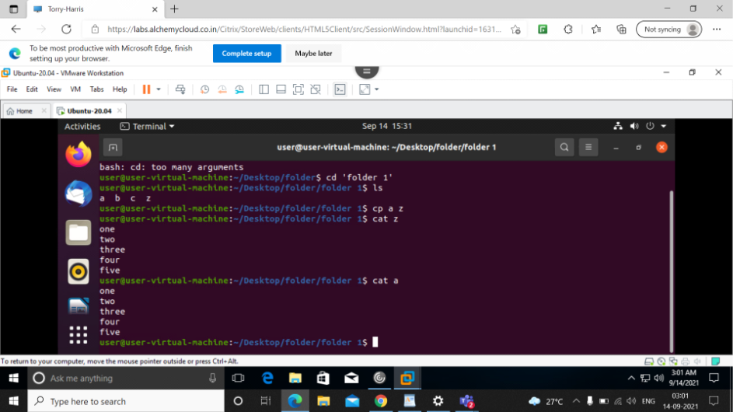
cat a command
displays everything in 'a'.

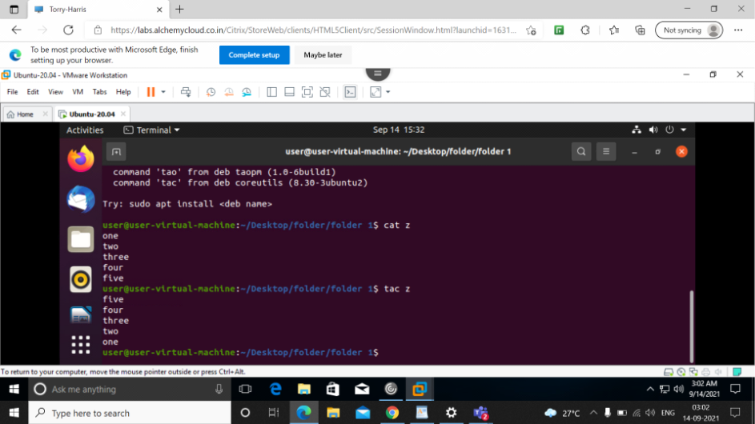
tac command
Displays the contents in reverse order
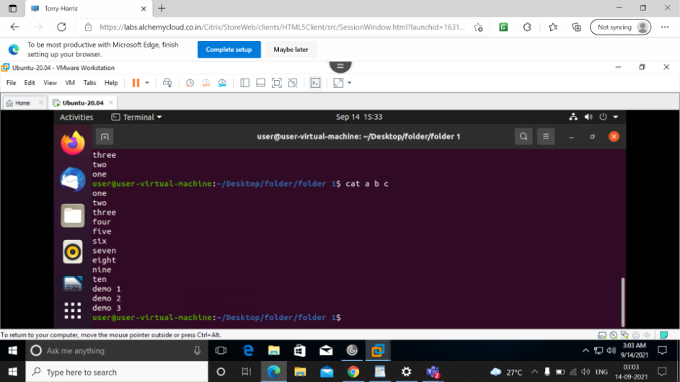
cat a b c
displays all file contents together (from file a b c)

